**His Eminence Metropolitan SABA**

|  |  |
| --- | --- |
| **RT. Rev. Archimandrite Fadi Rabbat** | Rev. Dcn. Miguel ‘Michael’ Sifuentes |
| Pastor | Deacon |

**“And the Disciples were first called Christians in Antioch”. Acts 11:26**

|  |  |  |
| --- | --- | --- |
| **Tel.: 915-584-9100** | [**www.stgeorge-elpaso.org**](http://www.stgeorge-elpaso.org) | **office@stgeorge-elpaso.org** |

**“My house shall be called a house of prayer for all nations.” Mark 11:17**

**SUNDAY, APRIL 21, 2024**

**Fifth Sunday of Great Lent**

**Commemoration of our Righteous Mother Mary of Egypt**

Hieromartyr Januarios, bishop of Benevento & companions; Martyr Alexandra the Queen & companions

**Divine Liturgy of St. Basil the Great**

**Tone 5/ Eothinon 2**

**Saturday Vespers Service:** **5:00 PM**

**Sunday Service:** **Orthros (Matins)** **at 9:15 AM, followed by Divine Liturgy at 10:30 AM**

**Sunday Epistle Reader:**  **Kyle Horton**

**RESURRECTIONAL APOLYTIKION IN TONE FIVE**

Let us believers praise and worship the Word; coeternal with the Father and the Spirit, born of the Virgin for our salvation. For, He took pleasure in ascending the Cross in the flesh to suffer death; and to raise the dead by His glorious Resurrection.

**APOLYTIKION OF ST. MARY OF EGYPT TONE EIGHT**

Through thee, the divine likeness was securely preserved, O mother Mary; for thou didst carry the cross and follow Christ. By example and precept thou didst teach us to ignore the body, because it is perishable, and to attend to the concerns of the undying soul. Therefore, doth thy soul rejoice with the angels.

**APOLYTIKION OF ST. GEORGE IN TONE FOUR**

Since thou art a liberator and deliverer of captives, a help and support of the poor and needy, a healing physician of the sick, a contender and fighter for kings, O great among Martyrs, the victory-clad George; intercede with Christ God for the salvation of our souls.

**ORDINARY KONTAKION IN TONE TWO**

O protection of Christians that cannot be put to shame, mediation unto the Creator most constant, O despise not the suppliant voices of those who have sinned; but be thou quick, O good one, to come unto our aid, who in faith cry unto thee: Hasten to intercession, and speed thou to make supplication, thou who dost ever protect, O Theotokos, them that honor thee.

**THE EPISTLE**

*Thou, O Lord, shalt preserve us and keep us from this generation.*

*Save me, O Lord, for the godly man hath disappeared.*

**The Reading from the Epistle of St. Paul to the Hebrews. (9:11-14)**

Brethren, Christ having appeared a High Priest of the good things to come, through the greater and more perfect tabernacle, not made with hands, that is to say, not of this creation; neither through the blood of goats and calves, but through His own blood, entered in once for all into the holy place, having found eternal redemption. For if the sprinkling of defiled persons with the blood of bulls and goats and with the ashes of a heifer sanctifies for the purification of the flesh, how much more shall the blood of Christ, who through the eternal Spirit offered Himself without blemish to God, purify your conscience from dead works to serve the living God?

**THE GOSPEL**

**The Reading from the Holy Gospel according to St. Mark. (10:32-45)**

At that time, Jesus took His twelve Disciples, and began to tell them what was to happen to Him, saying, “Behold, we are going up to Jerusalem. And the Son of man will be delivered to the chief priests and the scribes, and they will condemn Him to death, and deliver Him to the Gentiles. And they will mock Him, and scourge Him, and spit upon Him, and kill Him; and after three days He will rise.” And James and John, the sons of Zebedee, came forward to Him, and said to Him, “Teacher, we would that thou shouldest do for us whatsoever we shall desire” And Jesus said to them, “What do you want Me to do for you?” And they said to Him, “Grant us to sit, one at Thy right hand and one at Thy left, in Thy glory.” But Jesus said to them, “You do not know what you are asking. Are you able to drink the cup that I drink, or to be baptized with the baptism with which I am baptized?” And they said to Him, “We are able.” And Jesus said to them, “The cup that I drink you will drink; and with the baptism with which I am baptized, you will be baptized. But to sit at My right hand or at My left is not Mine to grant, but it is for those for whom it has been prepared.” And when the ten heard it, they began to be indignant at James and John. And Jesus called them to Him and said to them, “You know that those who are supposed to rule over the Gentiles lord it over them, and their great men exercise authority over them. But it shall not be so among you; but whoever would be great among you must be your servant, and whoever would be first among you must be servant of all. For the Son of man also came not to be served but to serve, and to give His life as a ransom for many.”

**THE SYNAXARION**

On April 21 in the Holy Orthodox Church, we commemorate the Hieromartyr Januarios, bishop of Benevento, and his companions; and the Martyr Alexandra the Queen and her companions.

On this same day, the Fifth Sunday of Great Lent, it was ordained that we make remembrance of our Godly Mother Mary of Egypt.

**Verses**

*Spirit rose up, flesh melted away erewhile; hide, O earth, the worn bones of Mary’s body.*

Once, during the Honorable Fast, the priest-monk Zosimus withdrew into the wilderness. He caught sight of a withered woman named Mary; her hair was white as snow. Mary then told Zosimus that she was born in Egypt and at the age of 12 began to live a life of debauchery in Alexandria for 17 years. One day, she went to Jerusalem to enter the church to venerate the Honorable Cross. However, some invisible force restrained her. In great fear, she gazed upon the icon of the Theotokos in the vestibule and prayed that she be allowed to enter the church, all the while confessing her sinfulness. She was then permitted to enter the church. Having venerated the Cross she again entered the vestibule and, before the icon, gave thanks to the Mother of God. At that very moment she heard a voice saying: “If you cross the Jordan, you will find glorious rest!” Mary left for the wilderness and remained there for 47 years in repentance. She bade Zosimus to come back in one year with Holy Communion, which he did. The following year, on Holy Thursday, April 1, 522, Zosimus discovered Mary’s lifeless body, and buried her. Thus, the Lord glorifies penitent sinners. The Church exalts and exemplifies Mary to the faithful in Great Lent as an incentive for repentance that brings entry into the Heavenly Kingdom.

Through her intercessions, O Christ God, have mercy upon us. Amen.



**Please note for Orthros, please turn to page 44 in the Red Service Book, and to**

**page 91 to follow along with the Divine Liturgy.**

**ONLINE LITURGICAL GUIDE FOR THIS WEEKEND**

**Please click on the following link to access the liturgical services for Saturday Vespers, Sunday Orthros and Sunday Divine Liturgy:** [Antiochian Orthodox Christian Archdiocese of North America](https://www.antiochian.org/liturgicday/3800)

**Click on the SELECT DATE in the top calendar. The services will appear under the DAILY LITURGICAL TEXT on the right column. Click on the service you need. You can follow the service using your cell phone or print a copy for your use.**

**WHO CAN RECEIVE COMMUNION IN AN ORTHODOX CHURCH?**

**Only Orthodox Christians who prepared for Communion through confession, prayer, and fasting can go up to the chalice to receive Communion from the priest. All visitors are welcomed to worship with us, however, non-Orthodox Christians may not partake of the Holy Eucharist but rather wait till the Dismissal of the Divine Liturgy and partake of the blessed bread (called antidoron) placed in front of the Solea.**

**We hope this will provide a clear understanding that the unity of the Orthodox faith is the required condition to partake in the Holy Eucharist.**

**HOLY BREAD ON SUNDAY IS OFFERED BY:**

Dalal Young for her health and that of her beloved family, Adan, Grace, Ethan and Evan Garcia.

Paul and Laila Ferris are offering the Holy Bread, which is used for the Eucharist on Wednesday’s Presanctified Divine Liturgies and Holy Week, in memory of Peter and Skee Rizk, Tom and Regina Jacobs, as well as for the health of the Rizk, Ferris, Cass, Samore, Al-Hanna, and Nasser families.

**DONATIONS**

Blanca Anaipakos in memory of Jean-Marc Salloum.

Allen & Patricia Borschow for flowers.

Jamie Isaac for the good health of Fr. Jehad Michael & family.

Natalia Gemchuk in memory of Gennady.

Esperanza Lozano for Palm & Easter.

Kristen Madsen in memory of Kh. Dina & Eliana Bahou, and for the good health of Fr. Anthony & Sub-Deacon Elias Bahou.

Odeh family for flowers for the health of our family.

James & Martha Shaheen for the good health of Fr. Michael & Bryan & Annette Haddad.

**ARCHDIOCESE DUES**

Blanca Anaipakos Esperanza Lozano Lisa Malooly

Rose, Coury, Gem & Monique Malooly

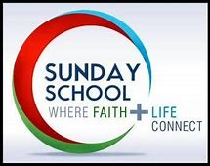 **SUNDAY SCHOOL**

Every Sunday students should be present at 9:25 AM to be with Fr. Fadi for the opening prayers.

**STUDENT ATTENDANCE ROSTER FOR SUNDAY, April 14th, 2024 – 12 students**

**Pre-School (ages 3 and 4 years old)** **Doris Shaheen**

Martha Gemchuk, Jack Horton & Seth Meza

**Grades Kinder/1st** **Jehan Al-Hanna**

Knight Joudi

**Grades 2/3** **Geoffrey Borschow**

Kingston Joudi

**Grades 4/5**  **Patricia Borschow**

Caleb Crawford

**Grades 6/7**  **Allen Borschow**

Melaina Horton & Sofia Meza

**Grades 8-12** **Jameelie Dayoub**

Christiana Crawford, Annabelle Horton, Andrea Meza & Anthony Meza,

**Sunday School Director** **Laila Ferris**

**Special Projects** **Jaclyn Ferris**

**Staff Assistant** **James Shaheen, Sr.**

**Staff Assistant Adriana Anzaldo**

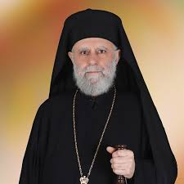

**TEACHINGS FROM METROPOLITAN SABA**

Dear parishioners and friends, you will periodically be receiving teachings by His Eminence Metropolitan **SABA** as we receive them from the Archdiocese Office. The teachings will be sent under a separate church email.

**THE ADULT STUDY GROUP**

As we continue our journey through the Great Lent, the Adult Study Group takes on a review the Gospel of John because it provides a narrative which is a general overview or summary (synopsis) of the events, as they had witnessed in the three years of Christ’s earthly ministry.

Please read the lessons associated with the Adult Study Group topic which will be sent under a separate church email.

-Dr. Sandra Edwards

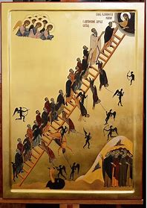 **THE LADDER OF DIVINE ASCENT BY ST. JOHN CLIMACUS**

On Sunday, April 14th, the Fourth Sunday of Great Lent, we remembered of our godly father, John, the author of The Ladder of Divine Ascent (or Climacus). John describes the method of elevating the soul to God as ascending a ladder. He teaches those who seek salvation how to lay a firm foundation for struggles, how to detect and fight every passion, how to avoid demonic snares, and how to rise from rudimental virtues to the heights of Godlike love and humility.

Please find attached to the church bulletin email an explanation of the steps of The Ladder of Divine Ascent by St. John Climacus.

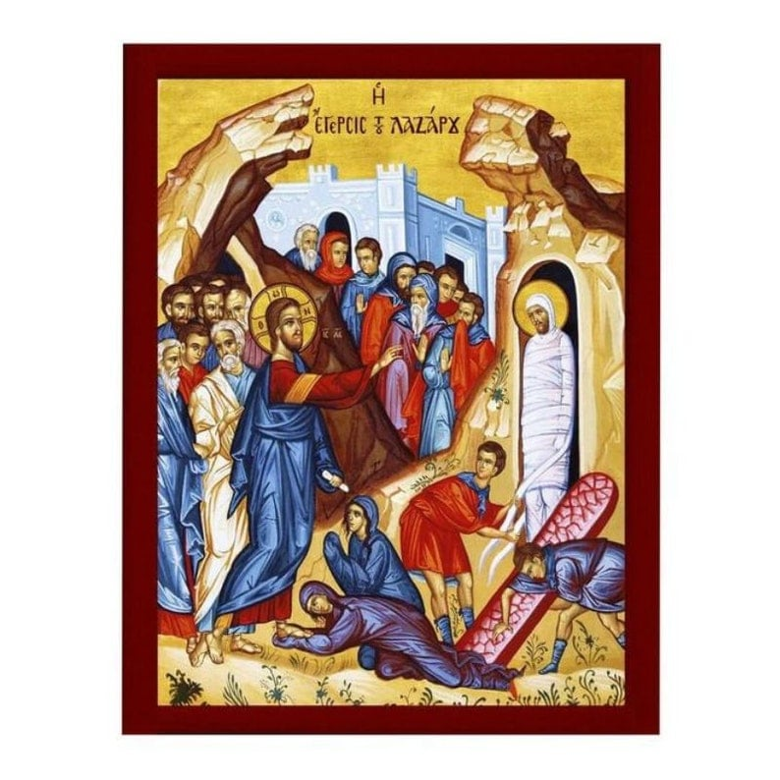

**LAZARUS SATURDAY REFESHMENT HOUR**

As is their yearly tradition, the Sunday School will be hosting refreshments after liturgy on Lazarus Saturday, April 27th, in the small hall in the Summit. A special bake session of St. Lazarus cookies will be held at the refreshment hour led by Maria and Geoffrey Borschow. Everyone is invited to join us.

Laila Ferris, Sunday School Director

**EASTER EGG HUNT**

The Teen SOYO sponsored by Chris Joudi and Goosehead Insurance will be hosting an Easter Egg Hunt for the children on Sunday, April 28, 2024, immediately following The Palm Sunday Divine Liturgy.



The Ladies will sponsor a Palm Sunday Luncheon after Liturgy on Sunday, April 28th in the Summit Ballroom The menu is baked fish, green beans, rice bread, salad, fruit and dessert.

Ticket prices are $20 for adults and $10 for children under 12. To reserve your tickets, contact: Jameelie Dayoub at (915) 497-5582, [**jameelie@aol.com**](mailto:jameelie@aol.com) **,** or Jamie Isaac at (915) 276-3436, **cedarfam4@aol.com**

Thank you for supporting the Ladies’ Society.

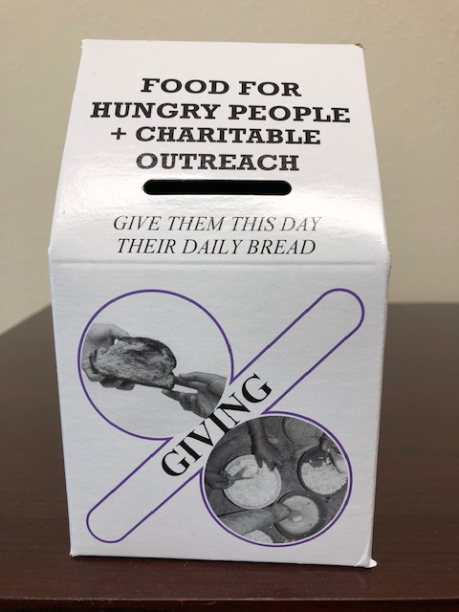**FOOD FOR HUNGRY PEOPLE & CHARITABLE OUTREACH**

**CAMPAIGN 2024 50TH ANNIVERSARY**

Many challenges are still being experienced within our families and our parishes across the country. One thing that never changes, however, is the power of Great Lent to strengthen us through prayer, fasting, and almsgiving. Let us again embrace our Lenten struggles and demonstrate how strong we are in our faith.

This year the archdiocese is encouraging you to design your own **FAMILY LENTEN COLLECTION BOX**, to be used in your own home. Be creative and decorate your own donation box or a Alms Box with a variety of sweets or craft decorations. When the box is filled, the children can make their donation and enjoy their yummy treats. We will take a picture of the boxes and send them when we submit the collected donations to the Food for Hungry People & Charitable Outreach program. The pics will then be posted on the Food for Hungry People & Charitable Outreach website.

We too have the customary **PARISH ALMS BOXES** available at the narthex (entrance) of the church.

All **ALMs BOXES** or donations need to be submitted to Tony Dayoub, Church Treasurer, by **Sunday, May 12th.** St. George will submit one check in the amount of the collected donations to the Food for Hungry People & Charitable Outreach Program.

Great Lent draws near! Let us renew our resolve to respond to the needs of those all around us and, in the process, renew our own faith.

**FINANCIAL DONATIONS TO PURCHASE FLOWERS TO DECORATE**

**FOR GOOD FRIDAY & PASCHA**

Financial donations received will be used to buy flowers to decorate the Bier for Good Friday and lilies for Pascha. Please donate in the health of your family or in memory of a loved one. Please make the check payable to the St. George. In the purpose line indicate ‘Donation for Flowers’. Thank you for your gift of love.

**ST GEORGE ICON PROJECT**

## *“*…*sanctify those who love the beauty of Thy house*.”

## **From the Prayer behind the Ambon from the Divine Liturgy of St. John Chrysostom**

Icons are representations of the Heavenly. They are expressions of Orthodox faith, teaching, and worship. The Orthodox Church uses icons to assist in worship. Icons are a 'window to heaven' and they help us to focus on the divine things.

Fr. Fadi is overseeing the Icon Project to have icons written on the interior walls that are bare in the church. This project is to continue beautifying the Church for the glory of God. **If you wish to make a monetary donation towards the Icon Project in memory of a loved one(s) and/or the health of your family, please contact Fr. Fadi at (973) 780-0221.** Please address your check to St. George Church, earmarked Icon Project Donation.

A warm thank you to all who have donated toward the Icon Project. Based on your gifts from the heart there will be more to come.

Please join us after church on Sundays for Coffee Hour in the small conference room in the Summit Hall.

If you are interested in sponsoring a Coffee Hour, please place your name on the SIGN-UP BOARD located in the small Hall in the Summit Hall.

**2024 MEMBERSHIP PLEDGE TO ST. GEORGE ANTIOCHIAN ORTHODOX CHURCH**

The minimum financial contribution of at least **$250.00 pledge per Baptized or Chrismated Orthodox person, ages 18 and older is required or $500 per family (or more from the gift of the heart).** This pledge is for the maintenance of the church. You can either pay your pledge immediately, or make payments throughout the year, however, the final amount must be met by December 31 of each year. **The met pledge of $250.00 makes you eligible to vote at the Annual General Assembly of Voting Members in January 2025.** Please make check payable to St. George Church in the donated amounts. In the purpose line indicate **Church Pledge**.

In addition, a yearly payment of thirty-five **($35.00) per Baptized or Chrismated Orthodox person** to the Antiochian Archdiocese of North America is required. Please make check payable to St. George Church in the required amount. In the purpose line indicate ‘**Archdiocese Dues.’**

If you have financial difficulties, please see the priest for available options.



**PRAYER FOR THE SICK**

Please let us know if you are ill and/or hospitalized by contacting Fr. Fadi Rabbat. We too will add your name to the prayer list for Sunday’s Divine Liturgy.

ivine Liturgy.

**CONTACT INFORMATION**

**For Pastoral needs and/or emergencies, visitation to hospital and/or homes during the year, contact Fr. Fadi Rabbat.**

**Confessions** are by appointment with Fr. Fadi Rabbat. **PLEASE contact Fr. Fadi TWO days in advance to ensure his schedule is free.**

**Fr. Fadi Rabbat at:**

***Cell phone***: **973.780.0221**

***Email***: **[fadi.rabbat@icloud.com](mailto:fadi.rabbat@icloud.com)**

Rev. Dcn. Michael Sifuentes at:

***Cell Phone:*** (915)309-1511 ***Email:*** [**deacon@stgeorge-elpaso.org**](mailto:deacon@stgeorge-elpaso.org)

**CHURCH BULLETIN STAFF**

The RT. Rev. Archimandrite Fadi, Chief Editor

Rev. Dcn. Michael, Editor

Vanessa Salloum, Assistant Editor

Jameelie Dayoub, Web Site

**Resources for the Evening Service**

For Great Compline, Liturgy of the Presanctified Gifts, and Friday Akathist services for the next five weeks, you'll want to key the following Antiochian Archdiocese site:  **https://www.antiochian.org/liturgicday**  
  
The link will take you to the Liturgics page. Scroll down to the very bottom of the page for 'Seasonal Liturgy Resources.' The section provides several services; however, the specific services you'll want are the following:   
  
1 - Great Compline on Monday:

At bottom of page click on **Great Compline in Great Lent – Full Text (PDF)**

2. - Liturgy of the **FIFTH** Presanctified Gifts on Wednesday evening:

At bottom of page click on **Presanctified Divine Liturgy – Full Text (PDF)**

**However**, there are some changes to hymns, prayers and gospel readings for each Wednesday Presanctified Liturgy. For the specifics, you'll want to scroll to the top of the page and key Select Date. A calendar will appear and you'll enter the Wednesday date. The information for the keyed Wednesday will appear on the right side of the page under Daily Liturgical Text. Click on **Presanctified Divine Liturgy (PDF)**  
3. - Little Compline with the Akathist Canon and stasis of the **FIFTH** Akathist Hymn on the evening Friday Akathist services:

For the specifics, you'll want to scroll to the top of the page and key Select Date. A calendar will appear and you'll enter the Friday date. The information for the keyed Friday will appear on the right side of the page under Daily Liturgical Text. Key the field **Little Compline (PDF)**

By linking to the **Resources for the Lent Evening Services** online site, as provided by the Antiochian Archdiocese, parishioners may either print or view the services from their cell phones to follow along when attending the services.

**LENT SERVICES SCHEDULE**

|  |  |  |
| --- | --- | --- |
| Great Compline | Monday, April 15  (5th Mon. of Lent) | 6:00 P.M. |
| Presanctified Divine Liturgy | Wednesday, April 17  (5th Wed. of Lent) | 6:00 P.M. |
| Little Compline with the Full Great Canon of Repentance by St. Andrew of Crete and the life of St. Mary of Egypt. | Thursday, April 18  (5th Thursday of Lent) | 6:00 P.M. |
| Little Compline with ALL Akathist (5th Friday) | Friday, April 19  (5th Fri. of Lent) | 6:00 P.M. |
| Great Compline | Monday, April 22  (6th Mon. of Lent) | 6:00 P.M. |
| Presanctified Divine Liturgy | Wednesday, April 24  (6th Wed. of Lent) | 6:00 P.M. |
| Little Compline with the Canon of the Raising of Lazarus | Friday, April 26 | 6:00 P.M. |

|  |  |  |
| --- | --- | --- |
| **Lazarus Saturday, Palm Sunday, Holy Week, Pascha & Agape**  **Services Schedule** | | |
| **SERVICE** | **DATE** | **TIME** |
| Saturday April 27 **A.M.** | Divine Liturgy of St. John Chrysostom for **St. Lazarus Saturday** | **9:15 A.M. Orthros**  **&**  **10:30 A.M.**  **Liturgy** |
| Saturday April 27 **P.M.** | Great Vespers for Palm Sunday | 5:00 P.M. |
| Sunday April 28 **A.M.** | Palm Sunday (**Glorious Entrance of the Lord to Jerusalem**) | **9:15 A.M. Orthros &**  **10:30 A.M.**  **Liturgy** |
| Sunday April 28 **P.M.** | 1st Bridegroom Service for Holy Monday (**Hada Houwwa Al-Khatan**) | 6:00 P.M. |
| Monday April 29 **P.M.** | Presanctified Divine Liturgy  2nd Bridegroom Service for Holy Tuesday (**Hada Houwwa Al-Khatan**) | 5:00 P.M.  6:30 P.M. |
| Tuesday April 30 **P.M**. | Presanctified Divine Liturgy  3rd Bridegroom Service for Holy Wednesday (**Hada Houwwa Al-Khatan**) | 5:00 P.M.  6:30 P.M. |
| Wednesday, May 1 **P.M**. | Presanctified Divine Liturgy  Service for the Sacrament of the Holy Unction (Salat Al-Zeit) | 5:00 P.M.  6:30 P.M. |
| Thursday May 2 **A.M.** | Orthros for Holy Thursday  Vesperal Divine Liturgy of St. Basil (**Mystical Supper**) | **9:15 A.M.**  **10:30 A.M.** |
| Thursday May 2 **P.M**. | Service of the Twelve Passion Gospels for Holy Friday | 6:00 P.M. |
| Friday, May 3 **A.M. & P.M.** | The Great (Royal) Hours and Typika on Holy Friday  Great Vespers for Holy Saturday (**Taking Down of Christ from the Cross**) | **9:15 A.M.**  3:00 P.M. |
| Friday May 3 **P.M.** | Orthros with the Service of the Lamentations for Holy Saturday  **(Followed with the All-Night Vigil by Teen SOYO.)** | 6:00 P.M. |
| Saturday May 4 **A.M.** | Vesperal Divine Liturgy of St. Basil the Great (**Qum Ya Rab**) | **9:15 A.M.** |
| Saturday, May 4 **P.M**. | The Vigil of Pascha - The Resurrection Rush Procession, Paschal Orthros, and Paschal Divine Liturgy of St. John Chrysostom for Sunday of Great and All-Holy Paschal | **10:00 P.M.** |
| Sunday, May 5 **P.M.** | Agape Vespers (**Gospel Readings in Multiple Languages**) with hymns for the commemoration of St. George | 5:00 P.M. |

**GREAT LENT FASTING GUIDELINES**

**Excluded Foods During Great Lent:**

**Meat and Meat Products**:  
Chicken, turkey, beef, pork, lard, items with beef gelatin and lard (certain breads and crackers)

**Dairy Products**:  
Cheese, milk, butter, eggs, lard, items with by-products of these products

**Fish**:  
Sardines, tuna, trout, bass, shark, pike, i.e., fish with backbones

**Oils**:  
Olive Oil

**Alcoholic Beverages**:  
Wine, beer, whiskey, etc.

**Permitted Foods During Great Lent**

**Shellfish**:  
Lobster, shrimp, crab, oysters, clams, mussels, etc.

**Vegetable and Vegetable Products**:  
Grains such as rice and wheat, pasta (non-egg), flour, vegetable gelatins

**Fruits and Nuts**:  
All varieties

**Oils**:  
Vegetable, margarine, corn, safflower, canola

**Miscellaneous**:  
Honey, soy, mustard, peanut butter